 | Tech Lead with 13 years of experience in leading and managing software development, Enterprise Architecture design and experienced in complete product cycle from analysis, architecture, design through development and deployment.  Role and Responsibilities  Work History |  |  | 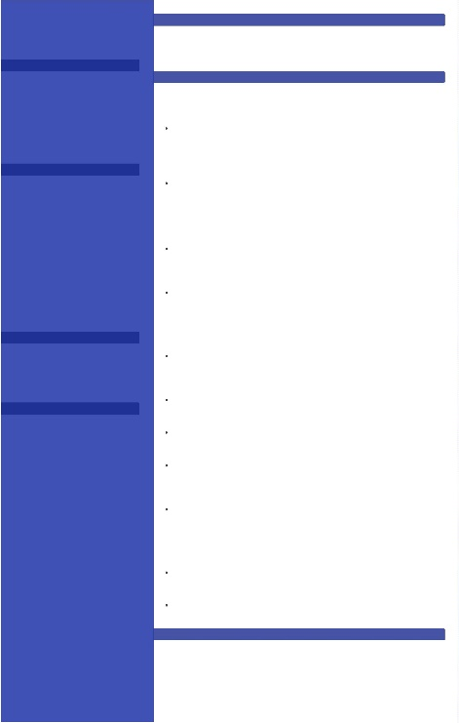  Contact  Address  Gurugram, India, 122403  Phone  +91-9643308575  E-mail  Invincible.amits@gmail.com  Skills  AWS  OpenShift  Docker  Linux  Unix/Shell  Automation  Jenkins  Chef  Grafana  ELK (Elastic)  GitHub  Data Analysis  ServiceNow  Certifications  2020-12  ELK Stack Edureka Certification  ITIL V3 foundation trained and certified  Education  Master of Computer Applications (MCA) from Utter Pradesh Technical University (2007)
  Amit Sharma
  - Responsible for managing the full life cycle of complex projects from requirements gathering, architectural design, High-level & Low-level design through partners & customers engagements.
  - Responsible to prepare long run project plans, annual roadmap, prioritized product backlogs
  - Collaborate closely with cross functional scrum teams, developers, tech owners to develop and deliver robust & scalable services.
  - Responsible to create resilient, fault tolerant, cost effective architecture in AWS cloud for the new applications.
  - Extensive knowledge on EC2, S3, VPC, route 53 etc AWS services.
  - Responsible to Work on Jenkins for continuous integration and for End-to-End automation for all build and deployments (OpenShift)
  - Responsible to manage Cloud Openshift Environment (Continues deployments, Fault tolerant architecture, cloud resource management)
  - Experience in working on devops tools like GIT, Jenkins, Chef and docker.
  - Experience in working on Jenkins for continuous integration and for End-to-End automation for all build and deployments (OpenShift)
  - Automating the infrastructure using configuration management tool Chef. Wrote many cookbooks to maintain the state of the software’s across the cluster of 100+ boxes.
  - Customizing Jenkin jobs in shell script to do database refreshes across environments, adhoc environment builds, pipeline creation for specific deployments, taking the backup of artifacts and rollback.
  - Getting the releases deployed into the production environment by closely working with infrastructure, release management, change management, QA, DBA and application teams.
  2018-09 – Till Date |  | Info Security Engineering Consultant  Optum Global Solutions (UHG)  Business Description: Identity and access management (IAM) facilitates the management of electronic or digital identities. Systems used for IAM include single sign-on systems, multifactor authentication, Active Directory and privileged access management. These technologies also provide the ability to securely store identity and profile data as well as data governance functions to ensure that only data that is necessary and relevant is shared.  Responsibilities:  - Responsible for managing the full life cycle of complex projects from requirements gathering, architectural design, High-level & Low-level design through partners & customers engagements.  - Responsible to prepare long run project plans, annual roadmap, prioritized product backlogs  - Collaborate closely with cross functional scrum teams, developers, tech owners to develop and deliver robust & scalable services.  - Responsible to create resilient, fault tolerant, cost effective architecture in AWS cloud for the new applications.  - Extensive knowledge on EC2, S3, VPC, route 53 etc AWS services.  - Responsible to Work on Jenkins for continuous integration and for End-to-End automation for all build and deployments (OpenShift)  - Responsible to manage Cloud Openshift Environment (Continues deployments, Fault tolerant architecture, cloud resource management)  - Responsible to create monitoring dashboards in grafana backed with bash script and telegraf
  2015-09 - 2018-06 |  | Senior Support Professional  RBS Gurugram  Business Description: The Operational Data Cache (ODC) is intended to be a core data service that can be used by Risk, Finance and Operations to access, update and manage shared data used in business transactions in a scalable and consistent manner. ODC is a highly distributed in-memory, normalized central repository data store designed for scalable data access and processing. The data includes trades, cash flows, valuation and reference data. ODC is built entirely on the oracle coherence technology and utilizing its different patterns  Responsibilities:  - Issue analysis, Identification of bug and the workaround. Response to functional queries, Understanding & analysis of user requirement for minor enhancements  - Performing production BAU activities, releasing code on time and to follow the process.  - Worked on user requirement for enhancements. Collaborating with management to create, improve and customize reports related to production support.  - Closely working with infrastructure, release management, change management, QA, DBA and application teams for release deployments.  - Managing off-shore, outsourced vendor to an SLA and execution of critical situations.  - Worked with various application module stakeholder to get the code rolled out to production.  - Troubleshooting deployment and installation issues.  - Handling complete Build and Release process including code, documentation and supporting testing team along with the server Administration  - Created various automations to keep an eye on system for 24x7.  - Take care of the weekend releases and make sure the business is available before working hours with minimal downtime.
  2010-03 - 2015-04 |  | Senior Support Professional  Genpact Head Strong  Description: Business functional domain is based on Credit Card, Store card, and other cards. There are more than 36 application & mixed infrastructure to support business beginning from origination to online account manager to payment processing.  Responsibilities:  - Managed off-shore for various production support activities, monthly deployments, bugfixes  - Closely worked with clients on various application migrations, DR activities, server migrations etc.  - Implemented build and deploy tools & Process to make smooth pipeline transition from Dev to Production.  - Worked on Github setup on an in-house ESXi machine  - Build, manage, and continuously improved the build infrastructure for software development engineering teams including implementation of build scripts, continuous integration infrastructure and deployment.  - Implemented continuous integration using Jenkins for various environments like dev, preprod.  - Using chef as CM to automate the infrastructure
  2007-07 - 2009-11 |  | Senior Support Professional  NTT Data  Description: Agile Business Suite enables the user to design, develop, test, debug, build and deploy large multi user applications to a Windows environment.  Agile Business Suite is a new software suite based on the proven robustness of Enterprise Application Environment (EAE) and emerging new technologies. Agile Business Suite hides the Complexity of leading-edge technologies so users can focus on business issues.  Application logic is specified in a technology independent manner. The business analyst specifies what an application must do and Agile Business Suite generates that application in the target environment. This enables users to build and deploy the exact business applications they need—when they need them.  .  Responsibilities:  - Managed off-shore for various production support activities, monthly deployments, bugfixes  - Worked for the development of Import/Export component of AB Suite Product.  - Provided fix to the issues arises in the product, in every release.  - Was responsible for the development of the module with the use of Vignette Portal Framework.
.

